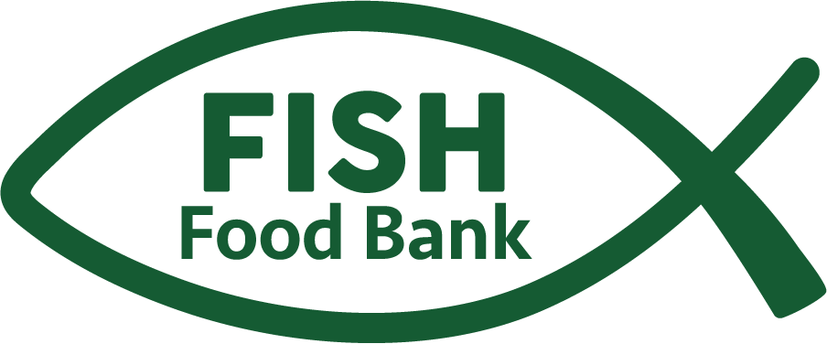 Because no one should be hungry
FISH Food Bank Food Drive Toolkit
Dear Community Partner,
Thank you for your interest in hosting a food drive to benefit FISH Food Bank. Every can, box, and dollar collected through your efforts helps our neighbors experiencing food insecurity.
With your help, we can continue to provide healthy, nourishing food to children, seniors, unhoused individuals, and hardworking families who just need a little extra support.
This toolkit includes everything you’ll need to plan, promote, and host a successful food drive—from suggested timelines, guideline & downloadable flyers featuring the FISH logo.
Thank you for joining us in this important work. Together, we are nourishing our neighbors and building a stronger, more caring Hood River County.
With gratitude,
Jacqueline Carey- Executive Director
And The FISH Food Bank Team
📍 Hood River | Parkdale | Cascade Locks
🌐 www.fish-food-bank.com
📧 fishfoodbankhr@gmail.com

3 Locations Serving Hood River County
Hood River Parkdale Cascade Locks
1130 Tucker Rd 4910 Baseline Dr 140 SE WaNaPa St
Hood River, OR 97031 Parkdale, OR 97041 Cascade Locks, OR 97014

📅 2. How to Run a Food Drive
Step 1: Plan
- Choose your dates. Most drives last 2–4 weeks.
- Select a collection method:
  - Physical bins or boxes- in an effort to be more sustainable, please use cardboard boxes you have around. Feel free to decorate them.
Step 2: Register Your Drive
Let us know you’re hosting a drive so we can support and recognize your efforts!
📧 Email: fishfoodbankhr@gmail.com
Step 4: Collect
- Clearly label donation bins with FISH posters or your own creative signage.
- Keep donations in a clean, dry space.
- Focus on healthy, non-perishable foods (see list below).
Step 5: Deliver & Celebrate
- Bring collected items to:
FISH Food Bank – Hood River Site (Main Warehouse)
1130 Tucker Rd., Hood River, OR 97031 -please call first so we can have volunteers on hand to help unload and weigh donations.
- Take photos and share your results—we love highlighting our amazing community partners!

🥫 3. Most Needed Food Items
Please donate healthy, non-perishable items such as:
- Canned tuna, chicken, or salmon
- Peanut butter and nut butters
- Canned fruits and vegetables
- Beans, brown rice, lentils
- Pasta and pasta sauce
- Ready to eat meals
- Whole-grain cereals and oats
- Canned soups and chili
- Condiments and cooking oil
🚫 Please avoid: expired foods, opened packages, or home-canned goods.
A printable MOST NEEDED ITEMS poster is HERE.

💳 4. Financial Donations
Monetary donations make an even greater impact—FISH can stretch every dollar to purchase fresh produce, dairy, meat, eggs and other essentials.
💻 Donate Online: https://www.fish-food-bank.com
📬 Mail Checks To:
FISH Food Bank
1767 12th St. No 147, Hood River, OR 97031

📣 5. Sample Promotion Materials
Social Media Caption:
Help FISH Food Bank nourish our neighbors!
We’re collecting healthy, non-perishable foods to support families across Hood River County.
🥫 Drop off donations at [location] by [date]!
#NourishingNeighbors #FISHFoodDrive
Poster Text (for Canva or PDF template):
Join Our Food Drive!
Help support FISH Food Bank and our neighbors in need.
📦 Drop off items here: [Your Location]
📅 Dates: [Insert dates]
Learn more at [your website]

